Checking Filebeat data on Kibana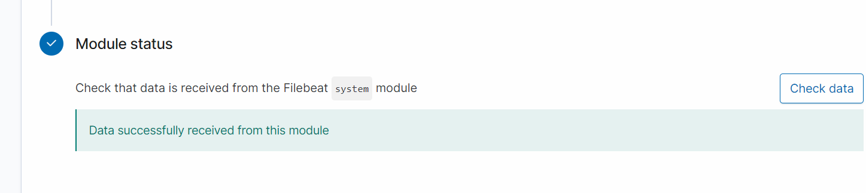

Checking metricbeat data on Kibana

